FIELD STUDY REPORT
of kuldiha
Balasore, odisha

Submitted to the S.R. college in
fulfilment for the award of Degree of Bachelor of
Science in Zoology
2022-23

By

Name : PRIYADARSHANI KAMILA
ROLL NO : 5907B22012
REGD NO : 12726/2022

UNDER THE SUPERVISION OF
DR. PUSHPA BIRULY

Department of Zoology
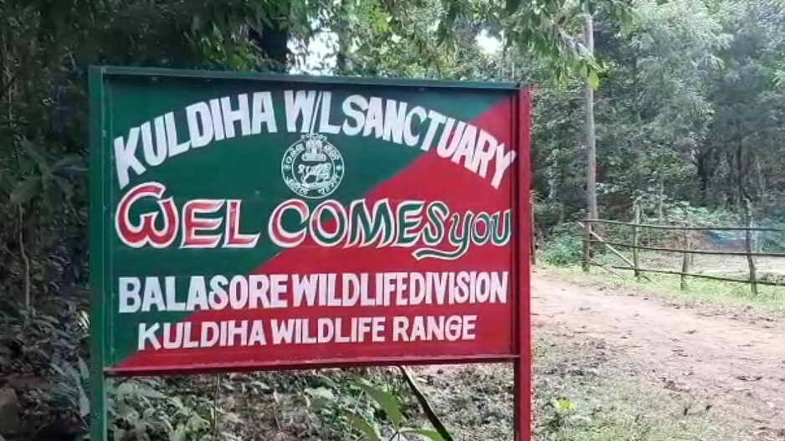
S.R. college Baliapal, Balasore

